**Lab sheet 07**

Q1: Probability that the train arrives between 8:10 a.m. and 8:25 a.m.

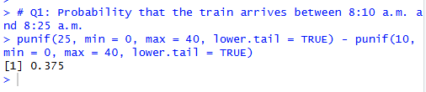

Q2: Probability that update takes at most 2 hours

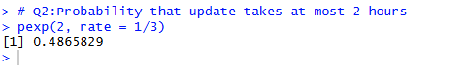

Q3: (i) Probability that IQ > 130



(ii): IQ score that represents the 95th percentile

